BeadLoom Game Vs Virtual Bead Loom
Comparing Learning in Educational Games and Tools
Acey Boyce, Shaun Pickford, Dustin Culler, Antoine Campbell, and Tiffany Barnes
Department of Computer Science
University of North Carolina at Charlotte
9201 University City Blvd., Charlotte, NC, USA
1-704-687-8577
Tiffany.Barnes@uncc.edu

ABSTRACT

Permission to make digital or hard copies of all or part of this work for personal or classroom use is granted without fee provided that copies are not made or distributed for profit or commercial advantage and that copies bear this notice and the full citation on the first page. To copy otherwise, or republish, to post on servers or to redistribute to lists, requires prior specific permission and/or a fee.
FDG 2010, June 19-21, Monterey, CA, USA
Copyright 2010 ACM 978-1-60558-937-4/10/06…$10.00.
BeadLoom Game (BLG) was developed to augment the Virtual Bead Loom (VBL) educational tool by providing motivational elements and game mechanics to encourage players to use the advanced functions of the tool. Previous research has proven BLG to be successful at teaching the concepts of the VBL, however no proof has been provided to show how its performance compares directly to that of VBL. In order to compare learning through playing the game to learning by use of the tool we ran a “switching replications” experimental design with two summer camps and found that the game results in statistically significant learning differences when compared to the original tool. We hope to use knowledge gained through these experiments to expand other educational tools into successful educational games.
Categories and Subject Descriptors
K.3.2 [Computers and education]: Computer and information science education. – computer science education.
General Terms
Design, Human Factors
Keywords
Game Development, Education, Motivation, Evaluation, Culturally Situated Design Tools.
1. INTRODUCTION

???

2. PREVIOUS RESEARCH

First CSDT

Then Boyce et al took it and incorporated game elements into it using the principles laid out by other papers people

Through a series of two experiments Boyce et al proved that Bead Loom Game did in fact teach the advanced concepts of Layering and Iteration while providing stronger internal motivation and replayability of the game. The first experiment was with a middle school summer camp that focused on CSDTs. Although no quantitative evidence was gathered on learning gains, it did show increased motivation to use the advanced functions. In the second experiment with a high school summer camp, they showed statistically significant increases from Pre-Test to Post-Test in the areas of Iteration and Layering after playing the game [Boyce et al, 2010]. Unfortunately, they need not directly compare the learning gains of the tool to that of the game. They also did not test the learning gains of middle school students, the original target audience of VBL.

3. SOFTWARE DESIGN
3.1 Original Virtual Bead Loom
Virtual Bead Loom is a Flash-based free-play tool which allows users to create their own Native American bead art by placing colored dots (beads) on a 41 by 41 Cartesian grid. To place the beads, users can choose from six different functions: Point, Line, Rectangle, Triangle, Linear Iteration, and Triangle Iteration. The Point function takes one point as its input parameter and places a single bead at the specified location. This is the simplest function in Virtual Bead Loom, and also the least efficient. All possible designs can be made by utilizing the Point function but, it would take 1681 function calls to completely fill the grid. Users can increase efficiency by using the other functions, which all put down multiple beads per function call. For example, the Line and Rectangle functions each take two points as their input parameters and create a line or rectangle of beads based on those points. The Line function places beads along the two points given, while the Rectangle Function fills in a rectangular region between the two specified points. Similarly the Triangle function takes three points for input, and uses them to create a triangle of beads. The Line, Rectangle and Triangle functions are slightly more complex than the Point tool, but it is observed that users quickly learn to use these functions successfully. The Iteration Functions are more advanced, and enable users to produce more complex patterns with a single call.
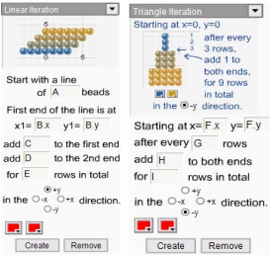
Figure 1 and 2: Linear and Triangle Iteration in the Virtual Bead Loom

As the name suggests, the Iteration functions use Iteration to place beads in complex patterns onto the grid. The first is the Linear Iteration Function (Figure 1). As indicated in the diagram above, this function begins with a straight line of beads of a given length (A) at a given point (B). It then moves to an adjacent space in a given direction and redraws the line, adding or subtracting a given number of beads from each side of the line (C and D) for the given number of lines total (E). The next function is the Triangle Iteration function (Figure 2). This function begins with a single bead at a given point (F). Then, for every given number of rows (G), the tool adds a given number of beads to each side (H). It does this for a given number of rows (I) and in a given direction.

All functions of the Virtual Bead Loom utilize layering: if you place one bead on top of another you will only see the top bead and no blending will occur. This is a simple implementation of the Painter’s Algorithm, a key concept in computer graphics. When rendering a scene using the Painters Algorithm, you start with the object farthest away from the screen on the Z-axis to avoid calculating which parts of the background are visible around obstacles. The same technique applies in VBL; it is much easier and far more efficient to begin with background layers than it is to try and add background around foreground objects.
The problem with VBL is that although students enjoyed using the tool they tended to only use the simpler functions, thus missing the learning gains from utilizing the advanced functions. Even when it would be much easier and faster to use an iterative function, students would add beads with the simpler functions, or even just points at a time. There was simply no internal motivation to use these functions.

3.2 BeadLoom Game
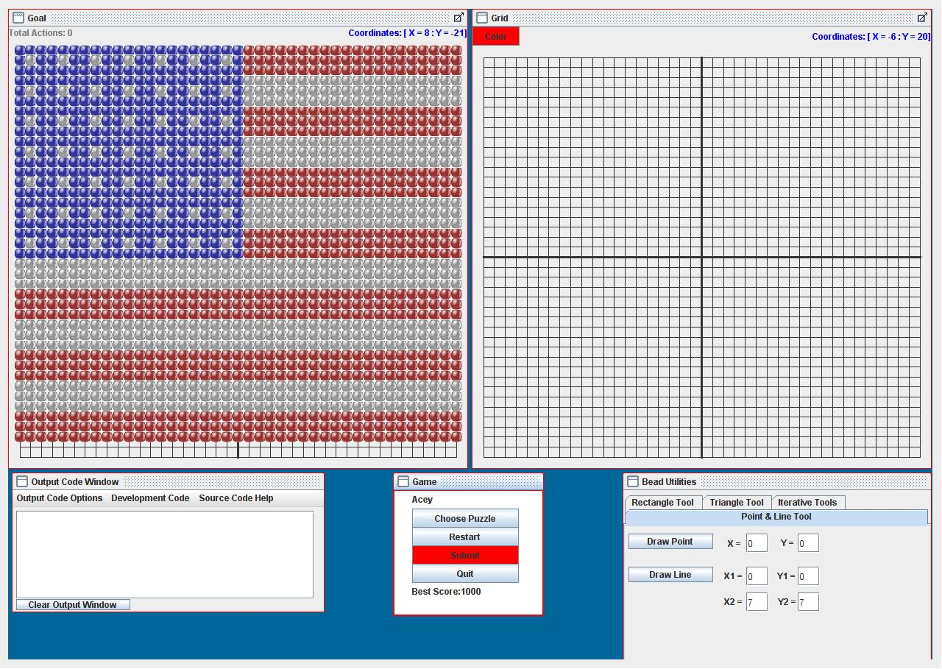
Figure 3: The BeadLoom Game
In order to provide internal motivation to use the advanced functions of VBL, we created BeadLoom Game. The main goal of BeadLoom Game is to create a goal image using as few moves as possible. Each time a player uses one of the six bead-placing functions it is considered one move. Whenever a player completes a puzzle they are awarded a medal based on their performance. By finding the lowest number of moves needed to complete the puzzle, or the ideal solution, the player earned a Platinum medal. If they completed it in up to 1.5 times the ideal solution they received a Gold medal, up to 2 times the ideal solution earned a Silver medal, and for just completing the puzzle they receive a Bronze medal. Although it is possible to earn Bronze medals simply by using the Point tool, players must learn and master the skills of Iteration and Layering in order to obtain Platinum medals. The medal system also encourages replaying of completed puzzles in order to find better solutions. This is especially effective in encouraging competitive game play between students on the more advanced puzzle where an ideal solution had not yet been found.

Through prior experiements, Boyce et al. successfully proved that BLG motivated students and taught the advanced topics. However, they did not show if it did so better than the original tool or even if it worked with the original target audience of middle school students. Showing this measurement was the motivation for our experiements.

4. EXPERIMENTAL METHODS
In order to compare the effectiveness of BeadLoom Game to Virtual Bead Loom, we tested them using a modified “switching replications” experimental design; an experimental design proven successful for comparing educational games to other curriculums [Eagle et al, 2009]. This was done at two summer camps held at the University of North Carolina at Charlotte in 2010. The first camp consisted of 21 middle school students: 15 male and 6 female. The second camp consisted of 20 college bound high school students: 13 male and 7 females. Each camp was 5 days long, with the first day devoted entirely to BeadLoom Game and Virtual Bead Loom. Before using either software, both camps completed a Pre-Test to gauge their understanding of Cartesian Coordinates, Iteration, and Layering. The Pre-Test consisted of 12 questions; four questions evaluating each subject area. The Cartesian Coordinates questions had the students to plot given points on a graph. The Iteration questions asked the students to fill in the missing numbers from an Iteration function (as shown in Figure 4), or find how many objects would be present after a number of iterations given an Iterative pattern. The Layering questions focused on finding the minimal number of shapes needed to make a given image.

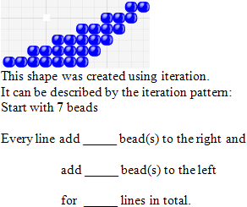

Figure 4: An example iteration question

Each camp was divided into two groups: one that played BeadLoom Game first (“Game Group”) and another that used the original Virtual Bead Loom Tool first (“Tool Group”). Both groups were then walked through a short demonstration of each of the six functions and then given 90 minutes to play the game or utilize the tools depending on the group. Afterwards, they were given an isomorphic Mid-Test to evaluate their learning gains.

After using the Game and the Tool respectively, each group was then switched to the opposite software. The Game Group was given Virtual Bead Loom to use, and the Tool Group was given BeadLoom Game to play. The students were instructed to use the new software for another 90 minutes. The remainder of the camps did not focus solely on the use of BeadLoom Game or Virtual BeadLoom. The middle school camp was introduced to other CSDTs, while the high school camp learned how to use Game Maker game development software. However, each day started off with a 30-minute BeadLoom Game Challenge. During this challenge we would select one puzzle and challenge the groups to see who could finish it with the fewest number of moves. In addition to this, at the end of each session students were given 30-60 minutes where they could choose from a selection of activities including BeadLoom Game and Virtual Bead Loom. During this time students were able to more freely explore all areas of the BeadLoom Game including the custom puzzle creator. Once some custom puzzles were created other students began attempting to find ideal solutions to their peers work.

At the end of the week, students were given an isomorphic Post-Test to evaluate overall learning gains. Students were also given a short survey to determine how they felt about the BeadLoom Game, what features they enjoyed most, and if they preferred BeadLoom Game or Virtual Bead Loom.

5. RESULTS
5.1 Middle School Group
Our first observation with the middle school group was that the
Game and the Tool were equally effective at teaching Cartesian Coordinates. This is not surprising, as the BeadLoom Game and Virtual Bead Loom have the same basic functionality for using and learning the Cartesian coordinates. The original tools ability to teach this subject was one of its strongest features and is the main reason for its use and thus we made sure the BeadLoom Game used the same interface.

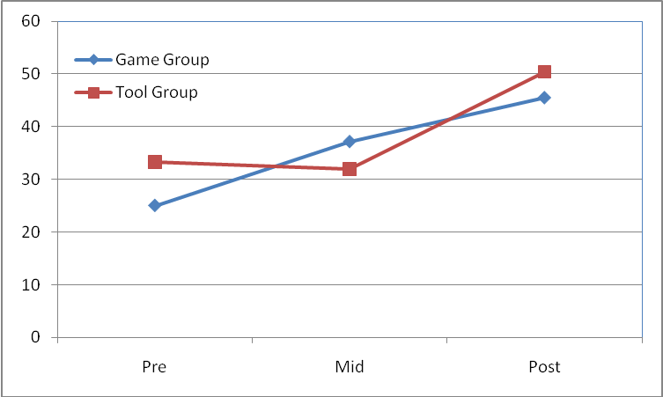
Figure 5: Middle school test results
Figure 5 shows the middle school students’ Pre, Mid, and Post-Test scores on the questions dealing with the subjects of Iteration and Layering. As illustrated in the figure above, the Game Group showed increases in knowledge during the first session and continued to learn through the remainder of the summer camp. The Tool Group did not show learning gains until after they began playing the game. Table # compares the learning differences between the groups for these questions. There was a significant difference in the learning gains from Pre to Mid-Test indicating that the Game Group learned more than the Tool Group from using only BeadLoom Game. The Tool Group was able to accomplish similar learning gains from Mid to Post-Test after they began using the game.

Table 1: Learning differences between middle school groups

 | N | Mid-Pre | Post-Mid | Post-Pre
Game | 11 | 12.12 | 8.33 | 20.45
Tool | 10 | -1.67 | 18.75 | 17.08
Difference p value |  | 0.019 | 0.27 | 0.70
t-stat |  | 2.57 | -1.12 | 0.38

During the week the students were introduced to one to two additional CSDTs every day through Wednesday. At the end of each of these days, students were given free time where they could work with any of the CSDTs we had introduced so far. As Table 2 shows, BeadLoom Game was the most popular selection every day.

Table 2: Free time CSDT selection by day

 | Monday | Tuesday | Wednesday
BeadLoom Game | 16 | 19 | 13
Virtual Bead Loom | 5 | 0 | 0
Other CSDT | - | 2 | 8

The middle school students gave BeadLoom Game an average rating of 3.88 out of 5. When asked which they preferred, 16 selected BeadLoom Game and 5 chose Virtual Bead Loom. When asked why one student responded “Because we have to solve with using our brains.” We also asked them to rank the CSDTs in order of preference. Virtual Bead Loom was ranked the fourth most popular while BeadLoom Game was ranked second. Over the course of the week long summer camp the middle school students managed to earn 183 Platinum medals and create many complex custom puzzles.
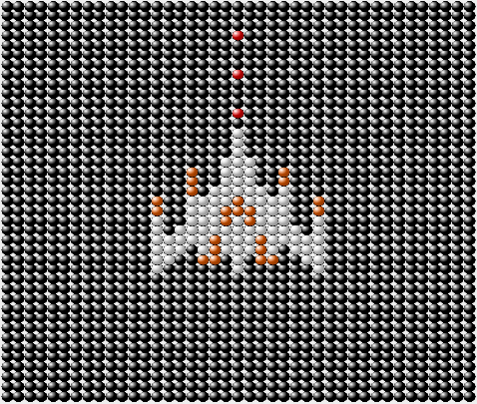
Figure 6: Middle school student custom puzzles

5.2 High School Group
Similar to the middle school group, the high school groups had statistically insignificant differences in the area of Cartesian Coordinates. This likely was a result from all the students already having a strong working knowledge of the Cartesian coordinates system and thus showing very little change from Pre to Mid-Test and through to the Post-Test.

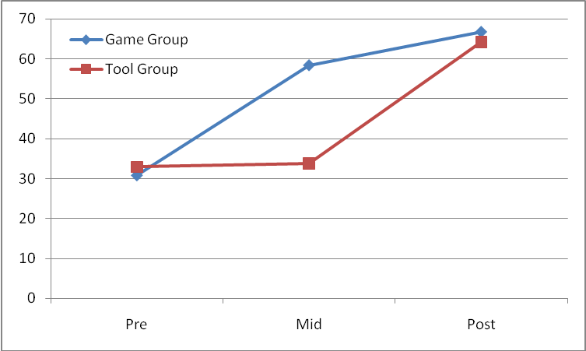

Figure 7: High school test results

Figure 7 shows the high school students Pre, Mid, and Post-Test scores on the questions dealing with Iteration and Layering. Like the middle school group, the Tool Group showed no learning gains during the mid test while the Game Group saw learning gains from Pre to Mid-Test and Mid to Post-Test. Once again the Tool Group only saw learning gains after playing BeadLoom Game. Table 3 compares the learning differences between the groups for these questions. There was a significant learning difference for the Game Group from Pre to Mid-Test and for the Tool Group from Mid to Post-Test; in other words, after exposure to BeadLoom Game. Like the middle school Tool Group, the high school Tool Group was able to overcome the initial learning gains difference and catch up to the Game Group by playing BLG.

Table 3: Learning differences between high school groups

 | N | Mid-Pre | Post-Mid | Post-Pre
Game | 10 | 27.50 | 8.33 | 35.83
Tool | 10 | .83 | 30.42 | 31.25
Difference p value |  | .0012 | .0031 | .63
t-stat |  | 2.57 | -1.12 | .49

The high school students gave BeadLoom Game an average rating of 3.5 out of 5. When asked if they preferred BeadLoom Game or Virtual Bead Loom 13 selected BeadLoom Game and 7 selected Virtual Bead Loom. When asked to explain their selection one student responded “The game forces me to use more complicated iterations to improve my score which makes it a fun activity and a good learning tool” which completely sums up the goal of this project. During their one week camp the high school students earned 215 Platinum medals and strove to create custom puzzles that surpassed the middle school students.

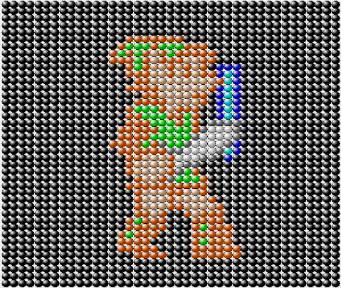

Figure 7: High school student custom puzzles

One final observation regarding the two summer camp groups is that the middle school games group outperformed the high school tool group on the mid test. The middle school games group averaged a 37.12% on iteration and layering while the high school tool group averaged a 31.67%. Although it was not by a statistically significant margin we were still surprised to see the middle school students outperform the college bound high school group after playing the game.

We can discern from our experiments that BeadLoom Game is more effective at teaching the advanced concepts of Iteration and Layering to both a middle school and high school audience. We also observed that using both the Virtual Bead Loom CSDT and BeadLoom Game was a good combination, as the original CSDT provides an easier environment to learn the basic concepts and experiment with the more advanced functions while the game enforces the knowledge of the advanced concepts. Full integration of Virtual Bead Loom CSDT into BeadLoom game would have yielded similar results with only one software package, and is something to be considered for future work and for all developers creating CSDT or other design tool-based games.
6. DISCUSSION AND FUTURE WORK

Our previous work with the BeadLoom Game proved that a game could teach the same concepts as an educational tool while being fun and motivating. However, it did not prove that it did this better than the original tool. It also lacked quantitative evidence that the tool worked with middle school students: the original target audience of the tool. This study accomplished both of these objectives. We have shown statistically significant learning gains for both the middle and high school game groups as well as the high school tool group after being exposed to the game.

This distinction between successful and more successful than the original tool was an important one to establish. We already knew games had a strong motivating force [Barnes et al. 2008; Garris et al. 2002], but this shows direct learning gain improvements resulting from the conversion of a successful educational tool into an educational game. If VBL can have its internal motivation and educational components augmented through the addition of challenge, objectives, and other game mechanics then perhaps others can as well. We hope to discover a way to easily add game features to other educational software to improve upon their learning gains while simultaneously increasing student’s motivation to use them.

There is still a great deal of research to be done on the BeadLoom Game and on the conversion of educational systems into more successful educational games. Based on feedback from users who prefer the Virtual Bead Loom we would like to run additional studies analyzing user preferences with and without custom puzzles. We would also like to expand to an online BeadLoom Game community and then run experiments to determine what effects the community aspects such as leaderboards and custom puzzles have on motivation and learning gains. If the community aspects are shown to be beneficial then we will integrate other educational games into this online collaborative community.

7. CONCLUSION

The results of the study showed that the BeadLoom game not only taught the intended concepts, but did so better than the original Virtual Bead Loom. The game showed statistically significant learning differences in groups of middle and high school students who used it when compared to groups who used the tool. By adding game elements we have been able to both increase student motivation to utilize and learn the tool and achieve higher learning gains than the tool in as little as 90 minutes. The data shows support for the premise of expanding this process to other successful educational software. Through the incorporation of game elements into educational software we can increase motivation and learning gains through fun and challenging objectives that directly correlate to learning objectives.

8. ACKNOWLEDGMENTS

This work was partially supported by the National Science Foundation Grants No. CNS-0634342 Improving Minority Participation in the Computing Pipeline, CNS 0739216 BPC-AE: The STARS Alliance: A Southeastern Partnership for Broadening Participation in Computing (2008-2011) and NSF-CNS 0540523 BPC-A: The STARS Alliance: A Southeastern Partnership for Diverse Participation in Computing (2006-2009), IIS-0757521, Game2Learn: Creative Computing Education, and the UNC Charlotte Diversity in Information Technology Institute.

9. REFERENCES
Barnes, T., E. Powell, A. Chaffin, H. Lipford. Game2Learn: Improving the engagement and motivation of CS1 students. ACM GDCSE 2008

Boyce, A., T. Barnes. BeadLoom Game: using game elements to increase motivation and learning. FDG 2010

Eagle, M., and T. Barnes. Experimental evaluation of an educational game for improved learning in introductory computing. In SIGCSE ’09, PP. 321-325, 2009

Garris, Ahlers, & Driskell. Games, motivation, and
learning: a research and practice model. Simulation and
Gaming, Vol. 33, No. 4, 2002, 441-467.

